1. Git clone

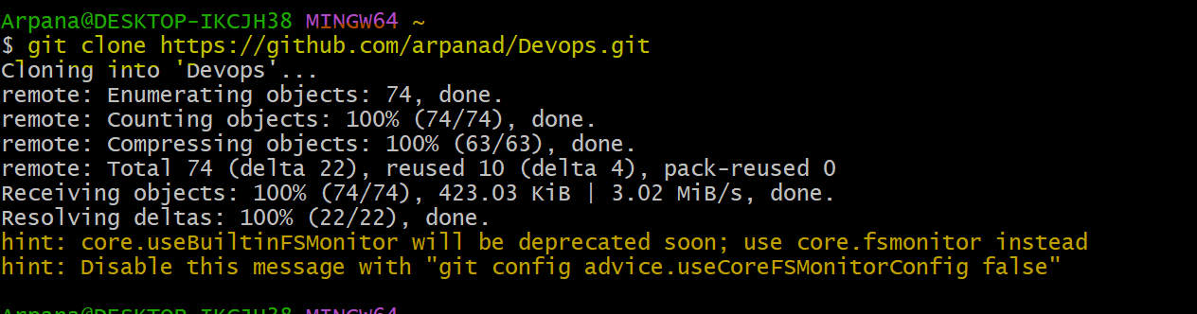

1. Git remote -v



1. Git status

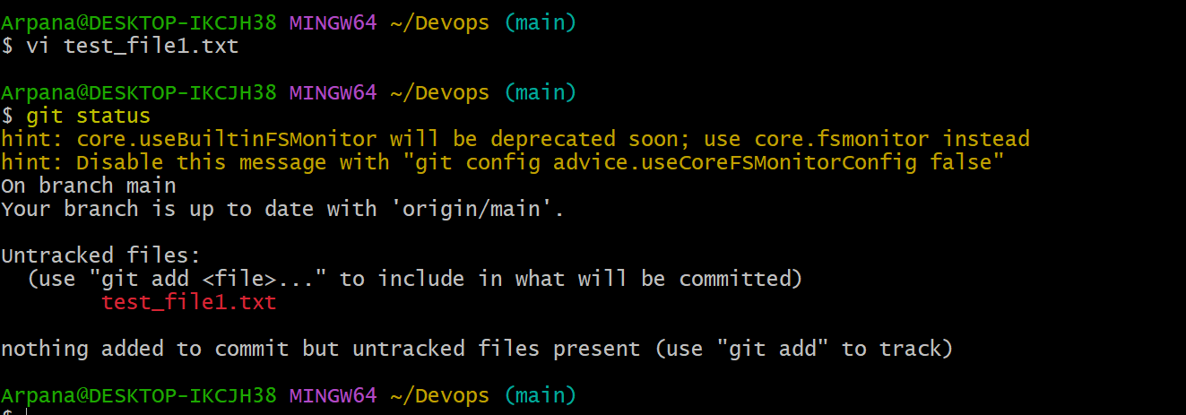

1. Git add

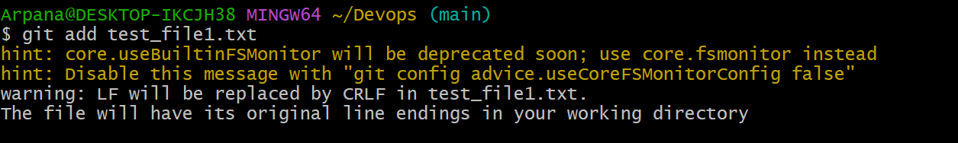

1. Git commit

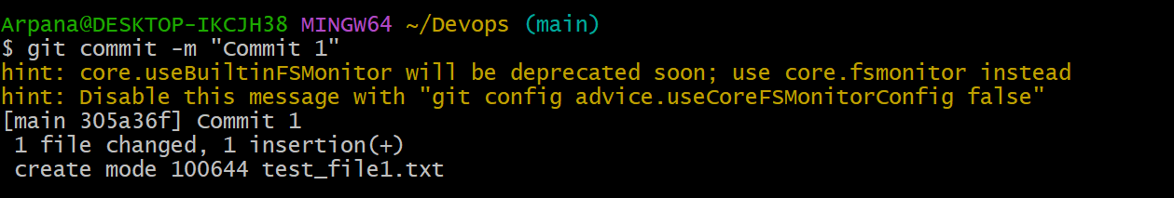

1. Git Push

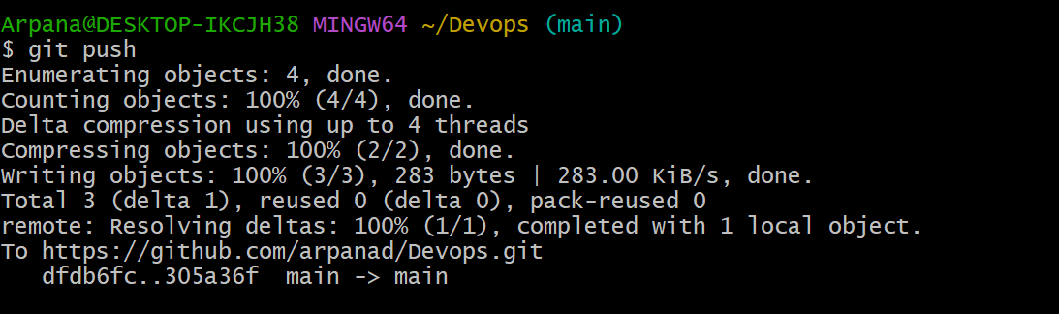

1. Git commit -am (amend)

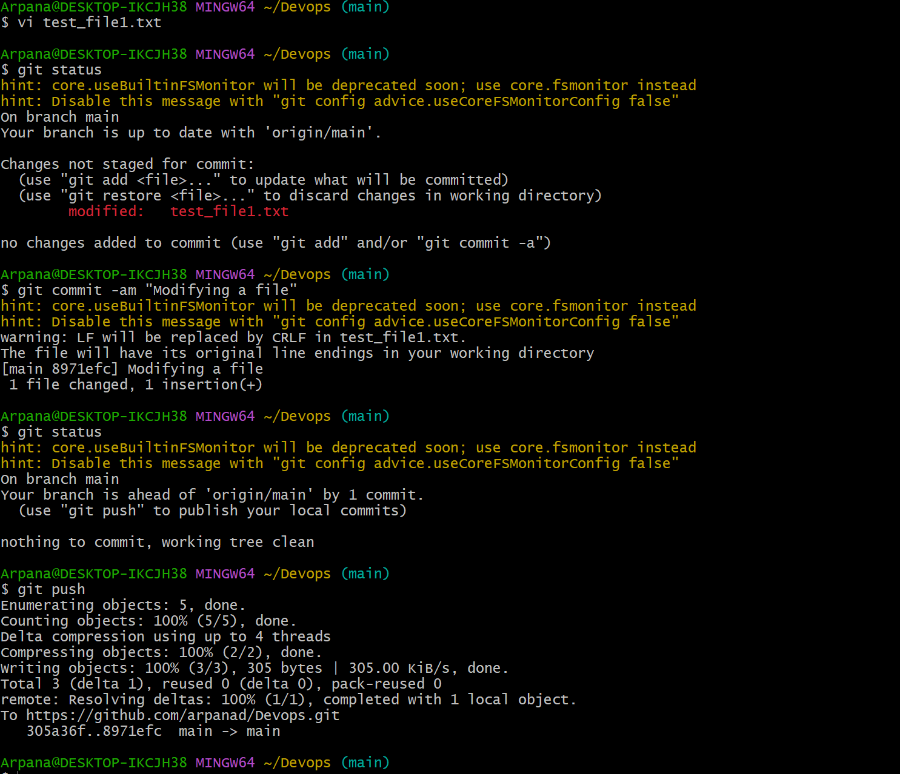

1. Git log

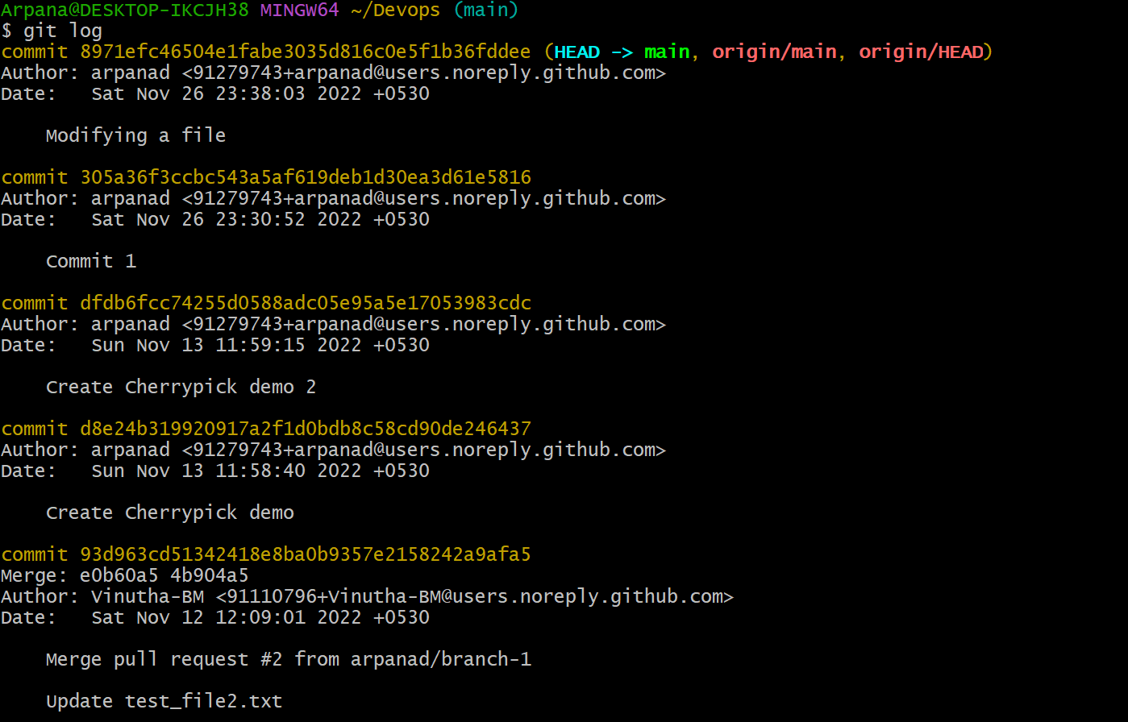

1. Git log -n

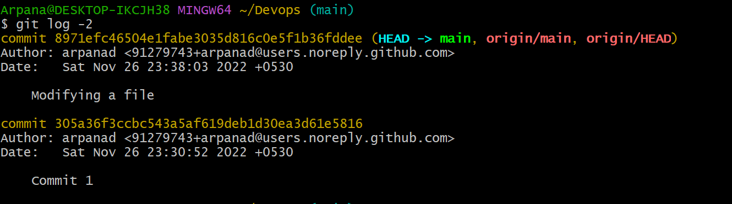

1. Git log –oneline

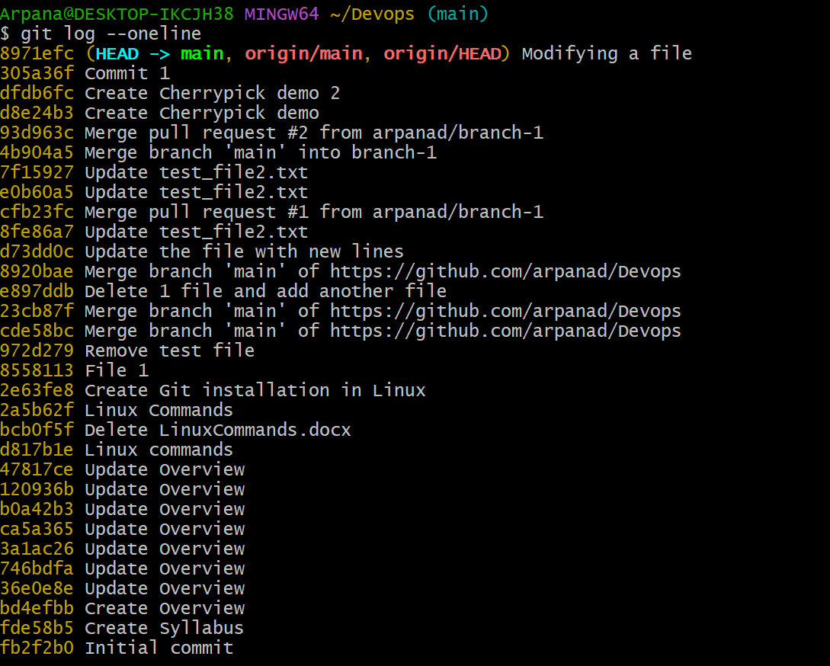

1. Git log – filename

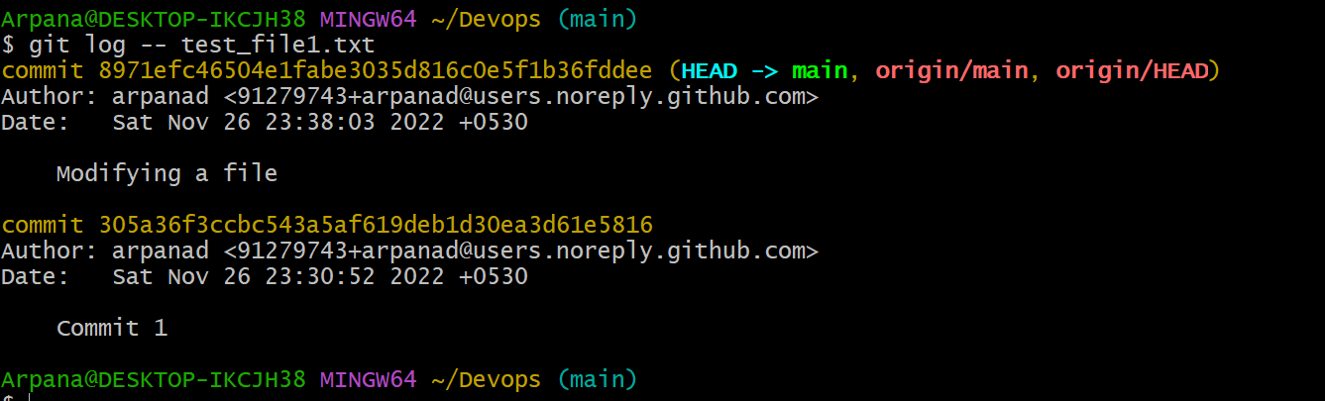

1. Git reset filename (tracked -> untracked stage)

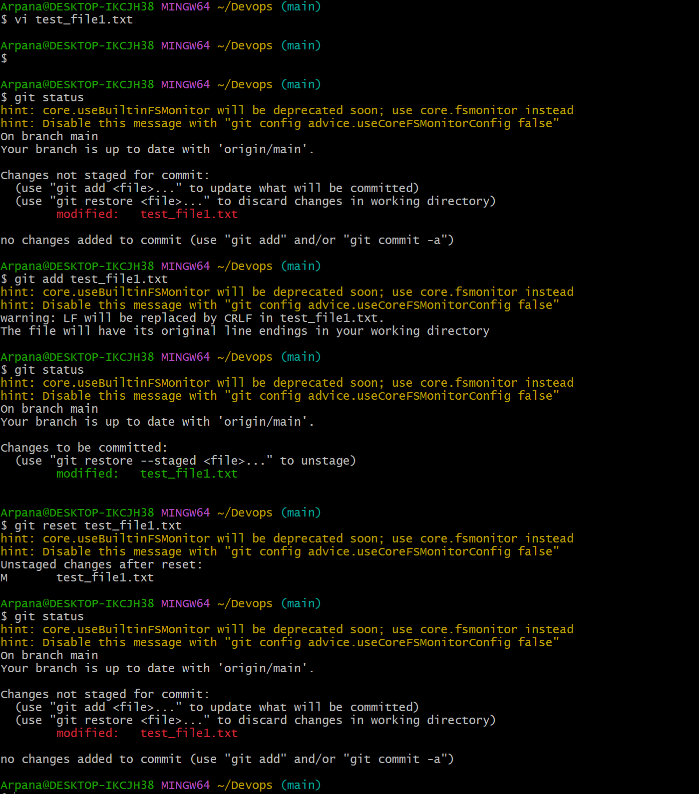

1. Git revert <commit id>

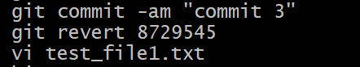

1. Git pull

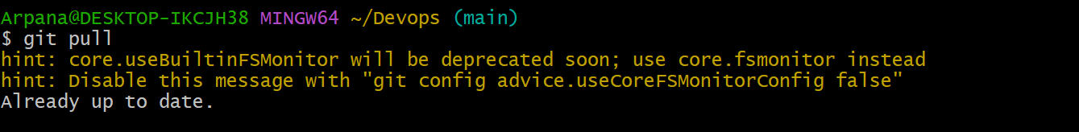

1. Git branch

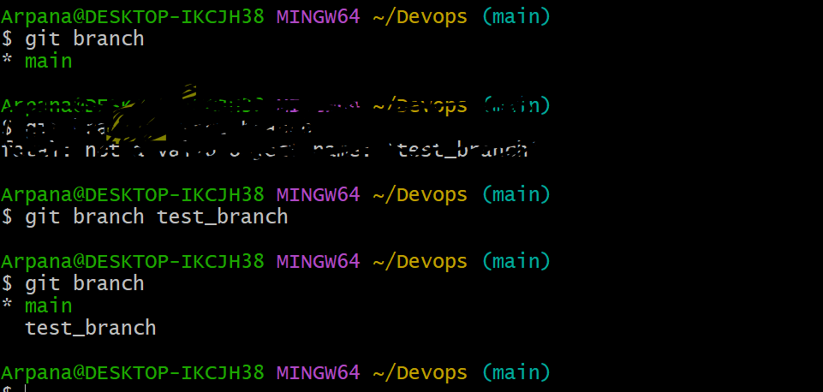

1. Git checkout <branchname>

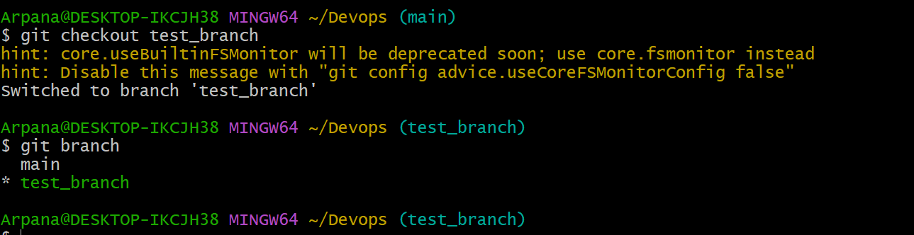

1. Git push origin <branch_name>

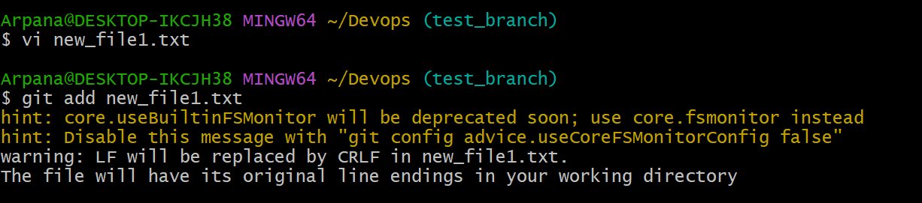

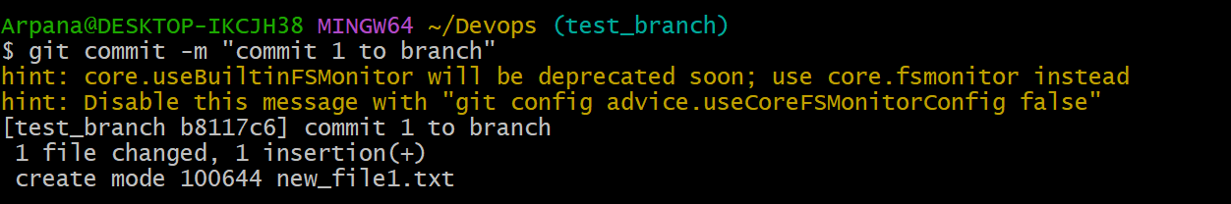

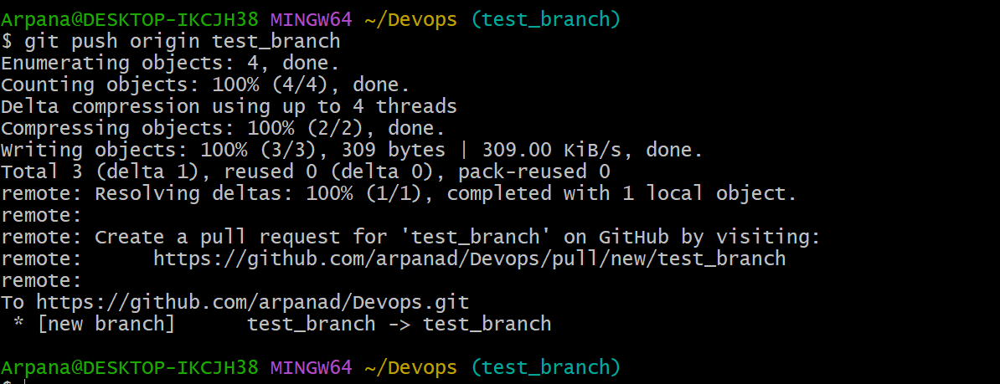

1. Git merge <branch_name>

